Practical AI
CA2 Report

Prepared by:
Tee Lin Kai (2415464)
Lai Jia Ler (2415914)
Thomas San (2415831)

Class: DAAA/FT/2B/02
Module: ST1508 Practical AI

TABLE OF CONTENTS

- Project Background and Sprint 2 Requirements
1.1 Project Background
1.2 Sprint 2 Scope and Objectives
1.3 Sprint 2 Functional Requirements (User Stories)
- Advanced Data Processing & Feature Engineering
2.1 Exploratory Data Analysis (EDA) & Data Quality
2.2 Feature Engineering
2.3 Outlier Detection and Handling
2.4 Dimensionality Reduction
- Machine Learning Experiments & Model Optimization
3.1 Experiment Orchestration & Collaboration (MLflow)
3.2 Data Preparation For Model Training
3.3 Phase 1: Baseline Establishment & Feature Selection
3.4 Phase 2: Handling Class Imbalance
3.5 Phase 3: Comparative Model Selection
3.6 Phase 4: Final Model Optimization
- Gobest Cab Safety Application: GUI Development
4.1 What We Implemented
4.2 Code Quality and Technical Standards
4.3 Feature Implementation vs. User Stories
4.4 System Assumptions, Constraints & Limitations

1. Project Background and Sprint 2 Requirements
1.1. Project Background
Gobest Cab is developing an AI system to analyze historical sensor data and detect dangerous driving behaviors. Following the data ingestion and analysis phase in Sprint 1, Sprint 2 focuses on training a predictive machine learning model and deploying it via an offline desktop application for real-time and batch safety analysis.
1.2 Sprint 2 Scope and Objectives
The primary goal of Sprint 2 is to engineer a machine learning model capable of predicting "safe" versus "dangerous" trip safety and to operationalize this model through a robust offline application. The specific technical objectives and quality constraints for this sprint are:
- Apply techniques such as feature engineering, high-dimensional outlier handling, and addressing class imbalance to prepare the dataset for modeling.
- Training and improving models through iterative experimentation, where refinements are guided by observed results rather than accuracy alone.
- Tracking experiments systematically using MLflow (parameters, metrics, artifacts, and the final selected model) to support comparison and reproducibility.
- Deploying the selected model into an offline Tkinter desktop application that supports both batch processing and real-time prediction.
1.3 Sprint 2 Functional Requirements (User Stories)
Role | User Story
Operations Manager | As an Operations Manager, I need to upload a batch file of sensor data into a desktop application, so that I can automatically identify reckless drivers from the previous week without performing manual analysis.
Safety Analyst | As a Safety Analyst, I need to input specific sensor readings into a GUI form, so that I can instantly assess if a specific trip was dangerous during driver incident reviews.
Fleet Manager | As a Fleet Manager, I need to view summary statistics of processed trips (percentage of dangerous drivers, total trips analyzed etc), so that I can identify safety trends and make data-driven decisions about driver training programs and fleet safety policies.
Company Manager | As a Company Manager, I need a user-friendly desktop application (GUI) that runs offline, so that my non-technical staff can use the AI system easily without needing Python knowledge.

2. Advanced Data Processing & Feature Engineering
2.1. Exploratory Data Analysis (EDA) & Data Quality
We began by validating the dataset's integrity, ensuring no null values or duplicates would compromise the modeling process. The most critical finding from this analysis was a severe class imbalance in the target variable (label). The "Safe" driving instances vastly outnumbered the "Dangerous" ones. We flagged this as a priority issue to address during training, as ignoring it would cause the model to bias heavily toward predicting "Safe" and miss actual dangerous events.
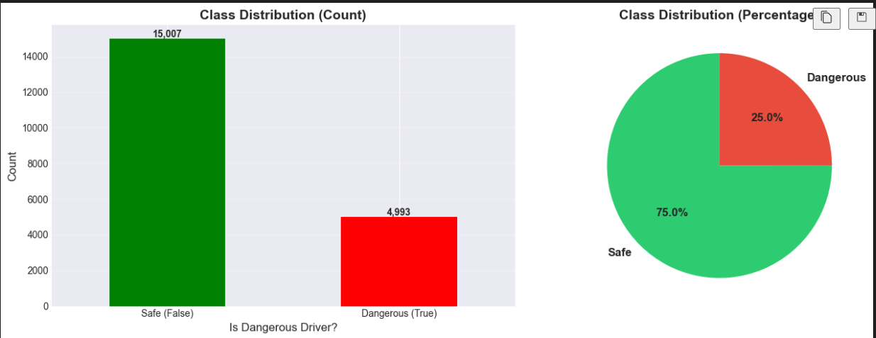
2.2. Feature Engineering
To extract meaningful patterns from the raw sensor data, we visualized the raw readings. As seen in the graph, dangerous driving events are characterized by sudden, high-intensity spikes in sensor values, whereas safe driving typically exhibits smoother patterns. To capture these patterns for the model, we engineered features focused on intensity and variation:
- Magnitude: We calculated the Euclidean norm for both accelerometer and gyroscope readings. This provided a rotation-invariant measure of total force, allowing the model to detect rough motion regardless of the direction.
- Statistical Aggregations: We computed the Mean, Standard Deviation, and Max for each trip segment. These metrics were crucial for distinguishing between the consistent readings of a steady drive and the erratic spikes typical of dangerous maneuvers.
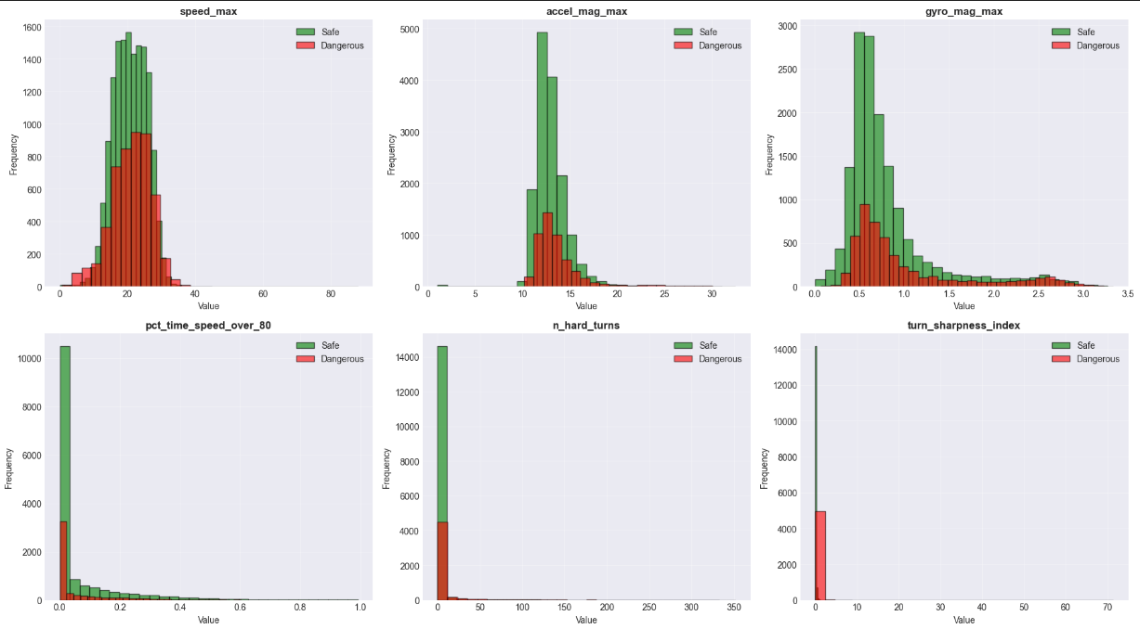
2.3. Outlier Detection and Handling
We utilized the Interquartile Range (IQR) method to filter out sensor noise and irrelevant spikes. We defined a statistical "normal range" and treated data points significantly outside this boundary as outliers. While we capped these extreme values to stabilize the model's training, we were careful to retain valid high-intensity readings that likely represented genuine dangerous driving events, ensuring the model could still learn from extreme scenarios. Note: “Outliers were already handled in the ETL pipeline (99.9% quantile clipping). These are 'natural' outliers within acceptable ranges.”
2.4. Dimensionality Reduction
With the addition of engineered features, the dataset grew in complexity. To maintain efficiency, we performed a correlation analysis to detect redundancy. Using a heatmap, we identified feature pairs with near-perfect correlation (e.g., Mean vs. Median). We removed these redundant features to reduce dimensionality, ensuring the model remained lightweight and focused on unique predictive signals rather than repetitive data.
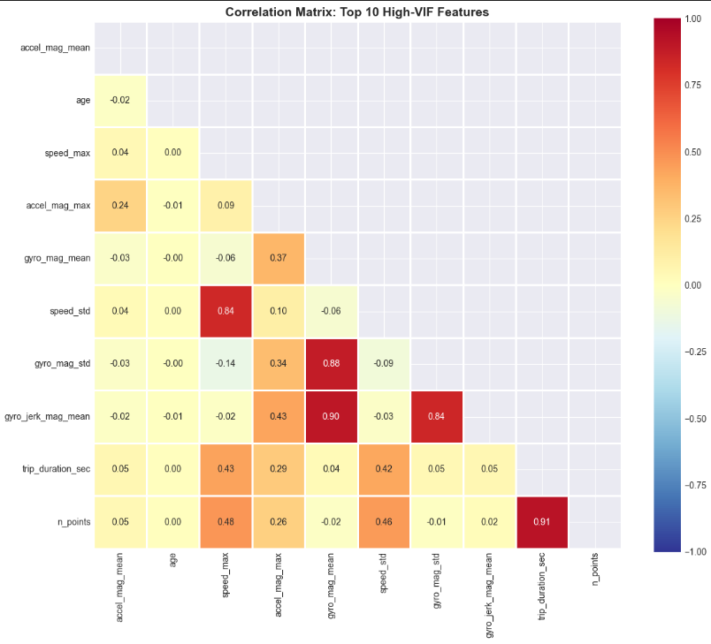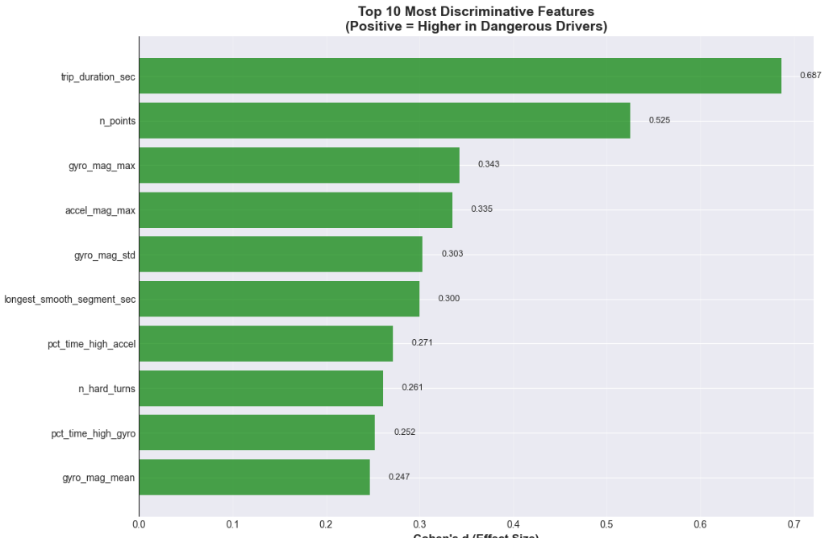

3. Machine Learning Experiments & Model Optimization
3.1. Experiment Orchestration & Collaboration (MLflow)
In a team-based development environment, maintaining a "Single Source of Truth" for model experiments is important. To avoid loss of information due to scattered notebooks and unrecorded parameters, we implemented MLflow as our centralized experiment tracking backbone. For every experiment conducted in Sprint 2, our pipeline automatically logged three distinct categories of data:
- Parameters: Critical configuration variables (e.g., regularization strength C, class weight distributions, and decision thresholds).
- Metrics: We prioritized Recall and F1-Score, while also tracking Accuracy, Precision and ROC-AUC to ensure a holistic view of performance.
- Artifacts: Serialized model files (.pkl), feature importance plots, confusion matrices and learning curve were stored for every run for further assistance in judgement.
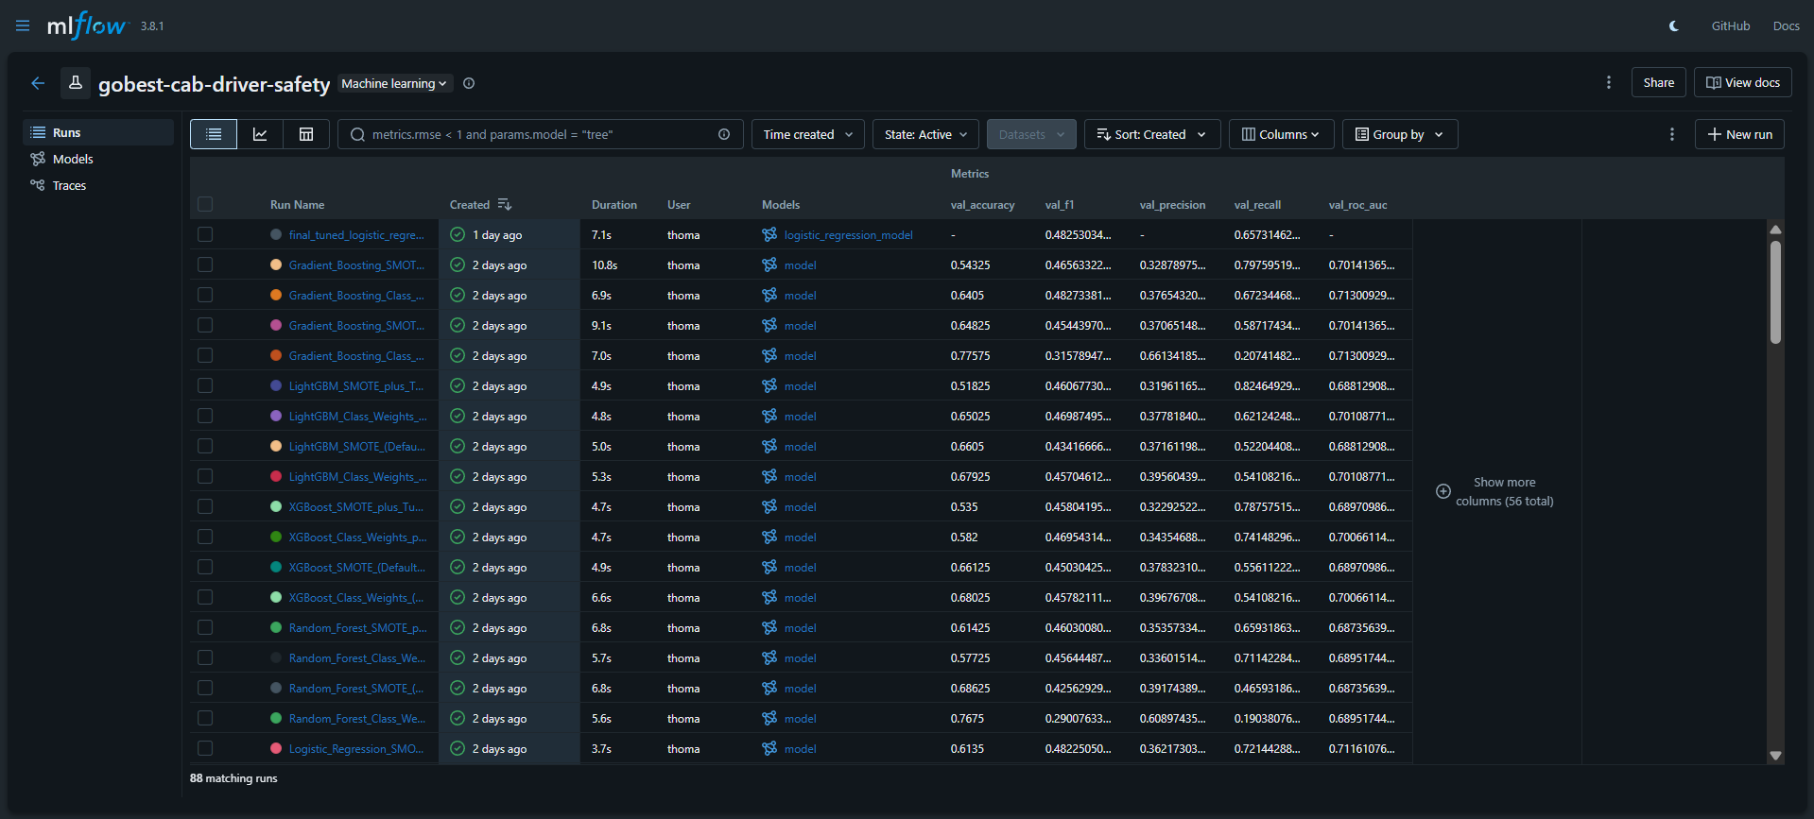
This setup enabled collaborative decision-making. Rather than relying on intuition and random search in notebooks, team members could pull up the MLflow dashboard, overlay results from different runs, and objectively validate whether a proposed change actually resulted in a statistically significant improvement.
3.2. Data Preparation For Model Training
Before modeling, we established a strict data partitioning strategy to ensure robust evaluation and prevent data leakage:
- Data Splitting: We split the data into a Training Set (60%), Validation Set (20%), and Test Set (20%). The Test Set remained strictly untouched until the final evaluation.
- Stratification: We used stratified splitting on the target variable (label) to ensure that dangerous trips were equally represented across all sets, preventing the "vanishing minority" issue.
- Feature Scaling: To handle the varying magnitudes of sensor data, we applied StandardScaler to the training data and transformed the validation/test sets using the same parameters.
3.3. Phase 1: Baseline Establishment & Feature Selection (Notebook 02)
We began Phase 1 with two objectives, to establish a performance benchmark and to immediately identify the minimal feature set required for the Safety Analyst GUI. We first trained a Baseline Logistic Regression model using the full set of 27 engineered features. This served as the reference point against which we could test our dimensionality reduction hypothesis.
Why Start with Dimensionality Reduction?
We prioritized feature selection immediately for two key reasons:
- User Perspective: The Safety Analyst User Story (Section 1.3) requires manual data entry. Starting with a "lean" feature set ensures the final product is usable. If we waited until later to reduce features, we risked building a complex model that could never be deployed in the intended GUI.
- Modeling Perspective: Training on high-dimensional data often introduces noise, where the model learns from irrelevant variations rather than the true signal. We aimed to evaluate feature importance early to determine if a subset could provide better generalization.

Experiment Analysis & Insights
We compared the full 27-feature baseline against a reduced 10-feature subset. The MLflow logs provided several critical insights that guided our next steps:
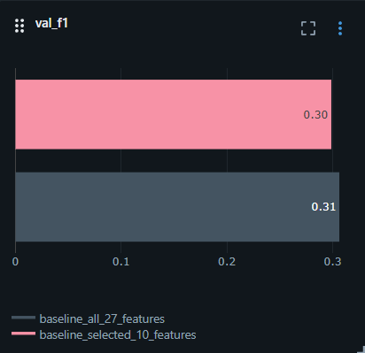
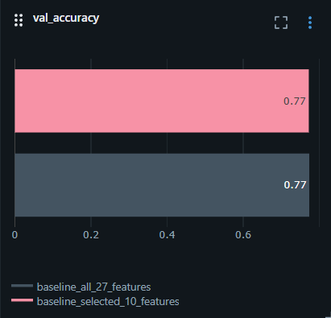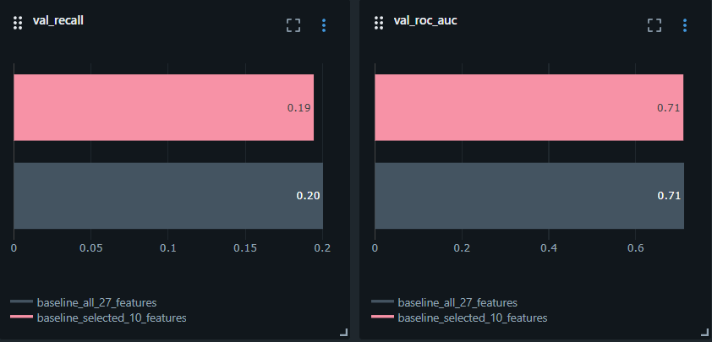
- High Accuracy, Low Recall: Both models achieved a seemingly respectable Accuracy of ~77%. However, the Recall was critically low at ~0.20, meaning the baseline model was failing to detect 80% of dangerous trips. This confirmed that while the model had some discriminative power (ROC-AUC 0.71), it was heavily biased towards the majority "Safe" class. This means we did not need more features; we needed to fix the class imbalance.
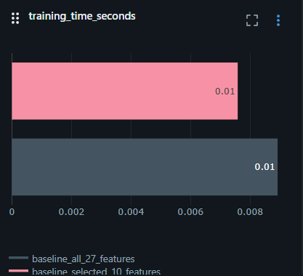
- Validation of the Reduced Feature Set: Comparing the two runs, the performance metrics remained remarkably stable. The F1-Score stayed constant at ~0.30, and the Recall did not degrade despite removing 17 features. This empirically proved that the discarded features (e.g., highly correlated variations of speed) were effectively "noise" that added computational weight without adding predictive signal.
- Efficiency Gains: The reduction decreases the model's training time. While negligible for a single run, this efficiency scales significantly when deploying the model into a real-time GUI environment, ensuring instant feedback for the end-user.
Decision: We proceeded with the 10-feature subset, carrying the known "Low Recall" issue forward as the primary objective for the next phase of experiment.
3.4. Phase 2: Handling Class Imbalance
To address the “Low Recall” issue, our objective was to make the model to prioritize dangerous drivers. We conducted a comprehensive experiment comparing Class Weights and SMOTE, both with default and thresholds tuning.
Experiment Analysis & Insights
We overlaid the results of all five configurations in MLflow to evaluate the impact on learning and decision boundaries.
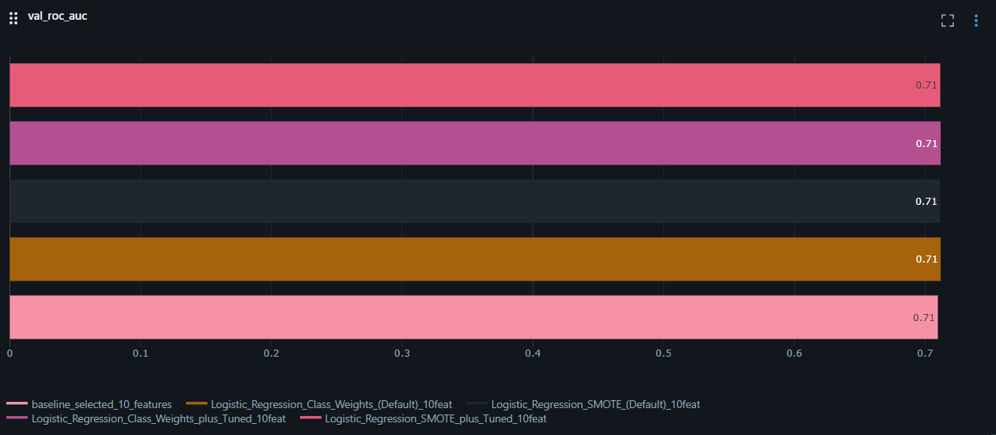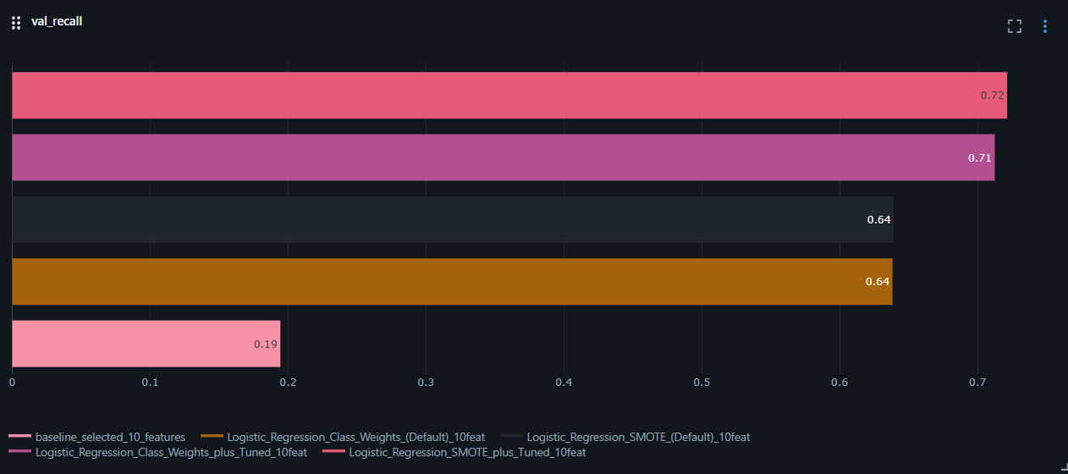
- Correction of Bias: Comparing the new runs against the baseline was a revelation. Both strategies immediately broke the model's habit of ignoring danger, tripling our detection rate from ~0.20 to ~0.64. This confirmed that fixing class imbalance was the primary driver for detecting dangerous trips.
- ROC-AUC Stability: Crucially, the ROC-AUC remained constant at ~0.71 across all phases. This proves that the baseline model already possessed the fundamental ability to distinguish dangerous trips (ranking power). The low Recall in Phase 1 was not due to a lack of predictive power, but purely due to decision bias.
- The "Forced Lean" of Tuning: The Tuned variants (Purple/Pink) pushed Recall further to ~0.72 but at the cost of Accuracy (~61%). This indicates that threshold tuning doesn't make the model "smarter"; it simply forces a safety-first trade-off, accepting more false alarms to catch every risk.
Decision: Based on the Logistic Regression results, we retained both Class Weights and SMOTE as neither strategy conclusively outperformed the other. To ensure a fair assessment of learning capabilities in the next phase of experiment, we chose to defer specific Threshold Tuning, carrying both imbalance strategies forward to test with more model architectures.
3.5. Phase 3: Comparative Model Selection
With our baseline established and imbalance strategies defined, we proceeded to the Model Selection phase. Our objective was to rigorously test whether complex, non-linear architectures could significantly outperform the Logistic Regression baseline in distinguishing dangerous drivers.
Why Do We Choose These Models?
We selected four specific ensemble architectures to challenge the baseline, aiming to target different aspects of predictive error:
- Random Forest: Selected to target variance. By averaging multiple parallel decision trees, we aimed to test if a "majority vote" approach could better handle the noise in the telemetry data compared to a single linear equation.
- XGBoost & Gradient Boosting: Selected to target bias. Unlike Random Forest, these models build trees sequentially to correct the errors of previous iterations. We included them to test if "forcing" the model to focus on hard-to-predict dangerous trips would yield higher Recall.
- LightGBM: Selected as a benchmark for efficiency. If a boosting approach proved necessary, we needed to verify if LightGBM could deliver similar performance with lower latency, ensuring the GUI remains responsive.
Experiment Setup (The Standardized Protocol): To ensure a strictly fair comparison, we enforced the same standardized testing protocol used in Phase 2. As shown in the MLflow sidebar, every model architecture was subjected to the exact same four configurations:
- Purple: SMOTE + Tuned Threshold
- Grey: Class Weights + Tuned Threshold
- Red: SMOTE (Default)
- Blue: Class Weights (Default)
The models are logged in a consistent vertical sequence from top to bottom: Gradient Boosting, LightGBM, XGBoost and finally Random Forest. Within each of these model groups, the four configurations follow the specific color-coded order listed above.
Experiment Analysis & Insights
We performed a cross-sectional analysis of all experimental runs in MLflow to determine if complex ensemble models could break the performance ceiling established by our baseline.
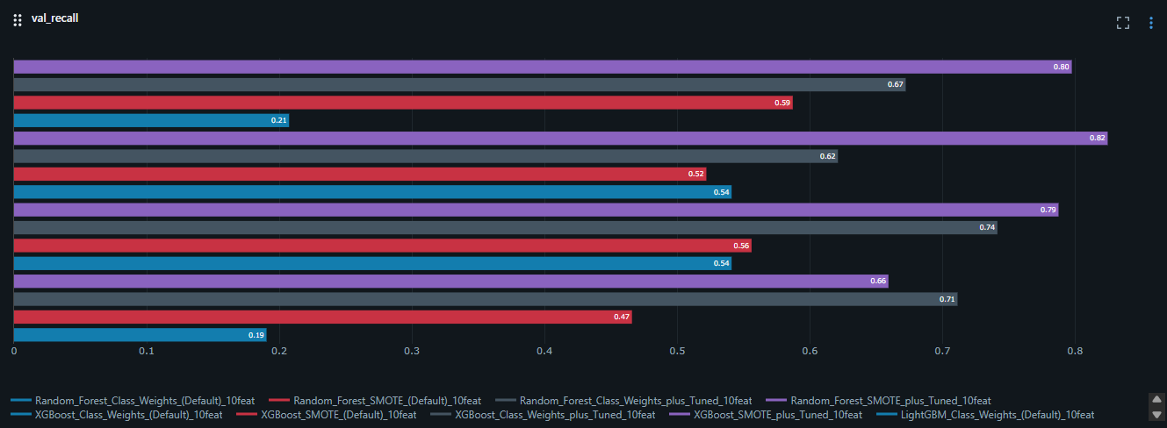
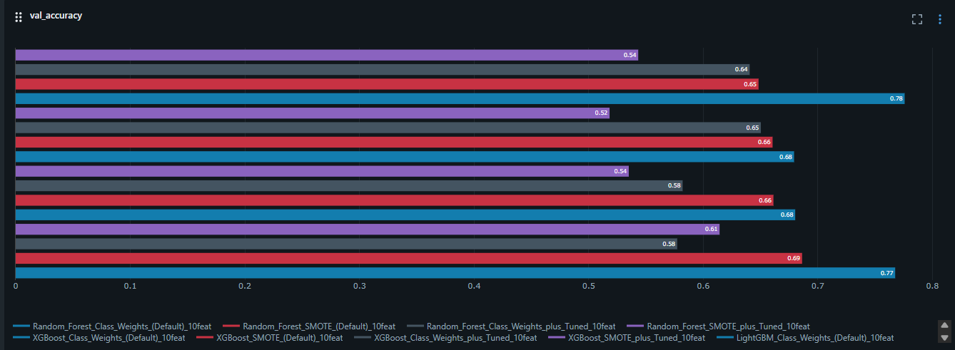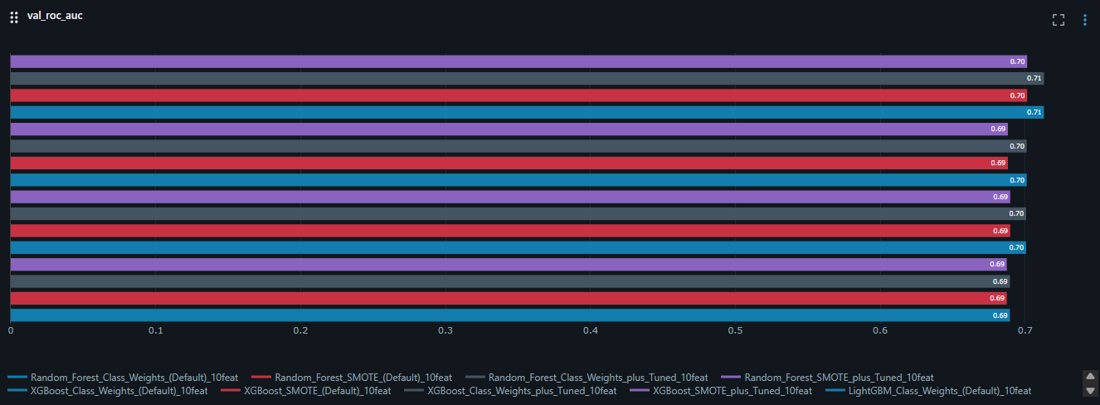
- Validation of Universal Traits: The experiments confirmed that the behavioral patterns identified in our Logistic Regression baseline are inherent to the dataset itself, rather than the specific algorithm used. For every architecture tested (Random Forest, XGBoost, LightGBM, and Gradient Boosting), Threshold Tuning consistently produced the same result: a significant boost in Recall accompanied by a sharp decline in Accuracy. Additionally, the gap between SMOTE and Class Weights remained negligible across all models, reinforcing our earlier conclusion that both strategies are equally capable of addressing class imbalance.
- The "Recall Illusion": At first glance, Random Forest (SMOTE + Tuned) appeared to be the winner with a peak Recall of 0.80, surpassing the Logistic Regression baseline of ~0.72. However, this gain was purely operational rather than a result of superior learning.
- The Accuracy Collapse: This 0.80 Recall came at a prohibitive cost; Accuracy plummeted to the 0.52 to 0.54 range. An accuracy of 0.52 suggests that the model is essentially guessing on nearly half of all trips to ensure it flags every potential danger. For a ride-hailing company like "Gobest Cab," this would result in an overwhelming volume of false alarms, rendering the Safety Analyst's job impossible.
- The ROC-AUC Plateau: The most critical finding was that ROC-AUC remained stagnant at 0.70 to 0.71 across every single model. Since ROC-AUC measures the model's fundamental ability to separate "Safe" from "Dangerous" trips, this proves that the ensemble models did not discover any new predictive signal that the baseline missed. They were not "smarter" than the Logistic Regression; they were simply being forced to be more oversensitive.
Decision: We have selected Logistic Regression (Class Weights + Tuned) as our final production model. It offers the optimal "sweet spot," achieving high Recall (~0.72) while maintaining an Accuracy (~0.61) that is significantly more usable than the 0.52 achieved by more complex ensembles. Furthermore, Logistic Regression provides the direct interpretability required for the Safety Analyst User Story, allowing for clear explanations of risk factors that "Black Box" models cannot provide without additional complexity.
3.6. Phase 4: Final Model Optimization
The final phase of development focused on refining our selected Logistic Regression model to its peak performance levels. Having addressed the primary "Low Recall" issue in previous phases, our objective shifted to maximizing the F1-Score to ensure the model was balanced for a live production environment. To move from a functional baseline to a deployment-ready asset, we performed the following:
- Hyperparameter Grid Search: An exhaustive search was conducted across 100+ combinations of regularization strengths (C) and penalty types. This was necessary to find the precise mathematical "sweet spot" where the model is regularized enough to ignore noise but flexible enough to capture complex driving patterns.
- ElasticNet Implementation: We transitioned from simple L1 or L2 penalties to ElasticNet. This allowed the model to leverage the strengths of both, improving its ability to handle feature correlations while preventing overfitting.
- Optimization for Balanced F1: We pivoted the optimization target from pure Recall to F1-Score. This was done to ensure the model caught enough dangerous trips (Recall) without overwhelming the Safety Analyst with an unmanageable volume of false alarms (Precision).
- Threshold Recalibration: We performed a final sweep of the decision boundary specifically for the tuned model to identify the "sweet spot" where the F1-Score was maximized.
Experiment Analysis & Insights
Using the experimental logs and visualizations, we analyzed the model’s behavior to confirm its stability and readiness for "Gobest Cab.
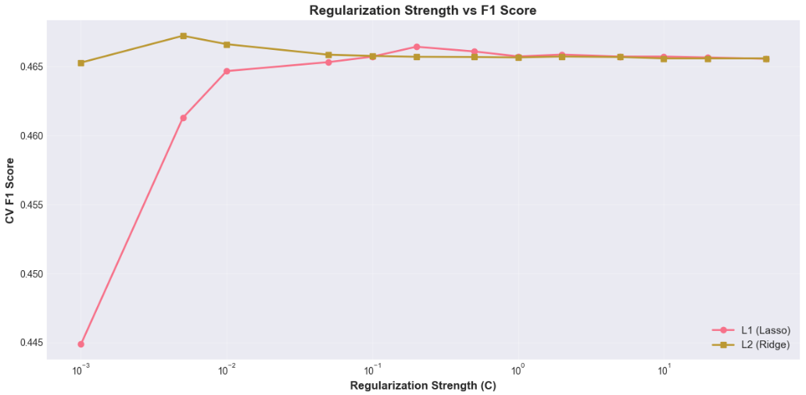
- The Regularization Sweet Spot: As shown in the Regularization vs. F1 graph, the model performance peaks at a specific C value. The curve demonstrates that too much regularization (low C) chokes the model’s ability to learn, while too little (high C) leads to diminishing returns in F1-score as it starts to overfit to noise.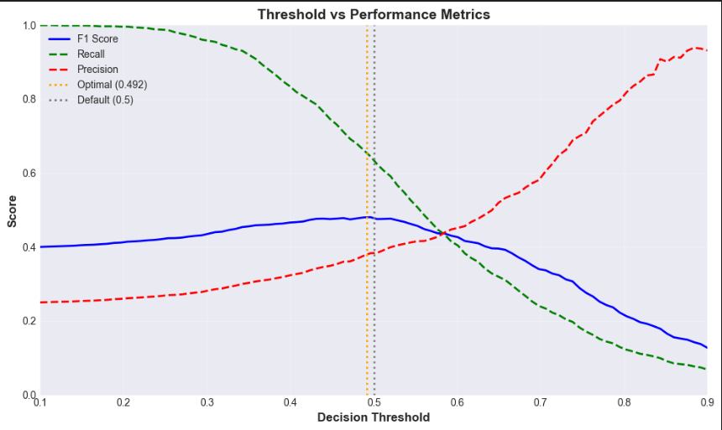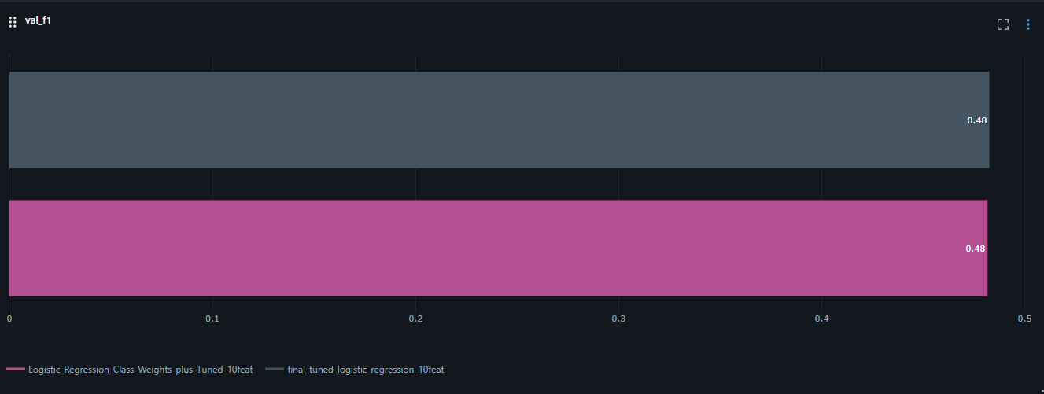
- Threshold Trade-offs: The Threshold Optimization plot illustrates the intersection between Precision and Recall. By identifying the point where these two metrics intersect, we achieved a Balanced F1 of 0.49. This confirms that we can catch 72% of dangerous trips while maintaining a precision level that keeps the Safety Analyst’s workflow manageable.
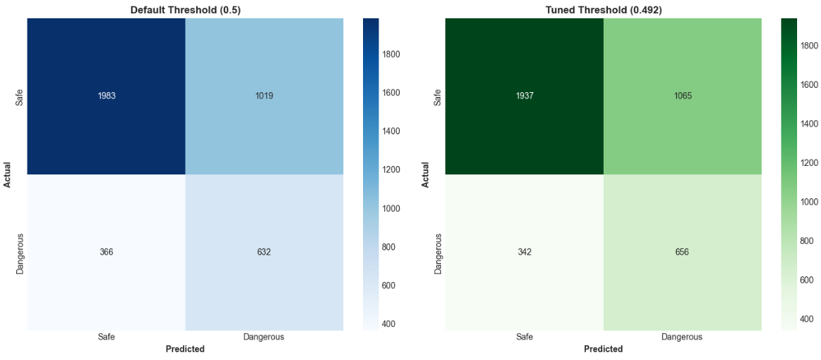
- Error Analysis (Confusion Matrix): Comparing the Default vs. Tuned Confusion Matrices reveals the impact of our strategy. The tuned model significantly reduces "False Safes" (Type II errors), which is our primary safety goal, shifting the model’s "opinion" to be more cautious without losing its ability to correctly identify safe drivers.
- Predictive Drivers: The Feature Importance (Coefficient Magnitude) chart reveals which telemetry signals the model relies on most. High absolute values for specific features (e.g., sudden acceleration or sharp steering) validate that the model is making decisions based on established risky driving behaviors rather than arbitrary data points.
- Generalization & Reliability: The MLflow Summary and final Test Set evaluation confirm that our metrics are consistent across training, validation, and untouched test data. This lack of variance proves that the model is robust and will perform reliably when integrated into the live GUI.
Decision: We have finalized the production version of the Logistic Regression model using Class Weights and an optimized ElasticNet penalty. By prioritizing the Balanced F1 Score over simple Accuracy, we have created a model that is both safe and operationally efficient.
Final Model Performance Summary
Precision | Accuracy | F1-Score (Balanced) | Recall | ROC-AUC
0.389 | 0.660 | 0.482 | 0.633 | 0.721
The following artifacts have been persisted for deployment:
- final_logistic_regression_tuned.pkl: The optimized model engine.
- feature_scaler.pkl: Necessary to normalize live telemetry before prediction.
- model_metadata.json: Storing the optimal threshold and feature list.
This completes the Machine Learning development pipeline. The model is now ready to be integrated into the Gobest Cab application to begin real-time risk detection.

4. Gobest Cab Safety Application: GUI Development
To deliver the optimized Machine Learning model to the Gobest Cab staff, a specialized desktop application was developed. This application bridges the gap between complex Python-based telemetry analysis and the operational needs of non-technical stakeholders, ensuring that safety insights are accessible, actionable, and entirely offline-capable.
4.1. What We Implemented
The application was engineered using an Object-Oriented Programming (OOP) approach to ensure the system is modular, scalable, and professional. By utilizing a Model-View-Controller (MVC) pattern, we decoupled the heavy processing logic from the user interface, allowing the application to remain responsive during intensive tasks.
- Dask-Powered ETL Engine: We implemented a high-performance backend using Dask for Extract, Transform, and Load (ETL) operations. This was a critical requirement for handling the Operations Manager's batch files, which can reach several gigabytes. Standard libraries like Pandas would often crash under such memory loads, but Dask allows the application to process data in memory-efficient chunks.
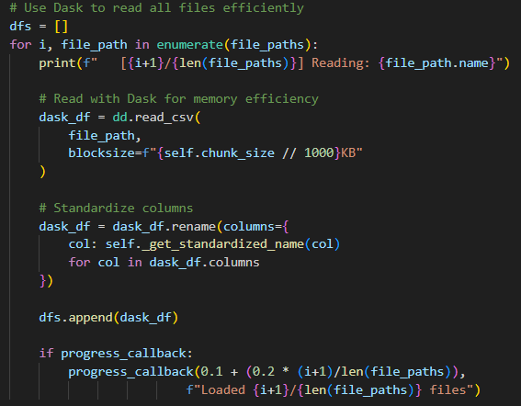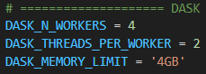
- Automated Feature Engineering Pipeline: A dedicated DataProcessor class was built to automate the translation of raw sensor telemetry into the 10 specific interaction features (e.g., turn_sharpness_index, accel_risk_score) identified during our training phase. This removes the need for manual calculations, as the system identifies the required columns and performs the math internally.
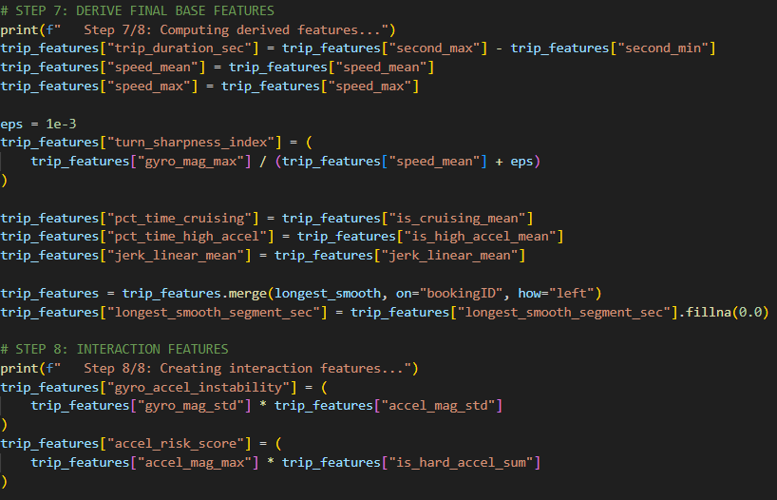
- Integrated Predictor Module: The Predictor class was designed to act as the "brain" of the terminal. It automatically loads the finalized Logistic Regression model and ElasticNet scaler as persistent artifacts. This ensures that the application applies the exact same mathematical weights and decision thresholds verified during Phase 4 tuning.
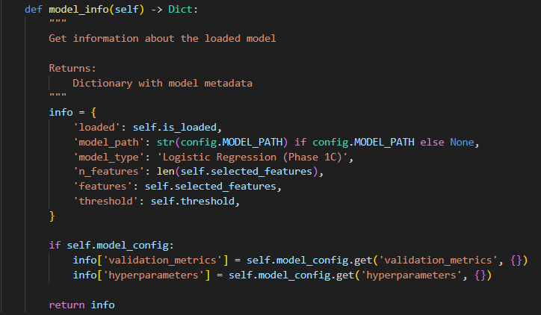
- Offline Tkinter Framework: To satisfy the Company Manager's requirement for a user-friendly system, we utilized the Tkinter framework. This allows the application to run as a native desktop tool without requiring an internet connection or any Python knowledge from the end-user.
4.2. Code Quality and Technical Standards
Beyond basic functionality, the application was built to rigorous technical standards to ensure it is production-ready and maintainable.
- Error Handling and Validation: The system features a multi-layer validation protocol. Before any data reaches the Machine Learning model, the DataProcessor validates file sizes, CSV extensions, and required sensor columns. This ensures that only high-quality, standardized data is used for safety predictions, protecting the model from producing something a user doesn’t want. In the event of an error such as a corrupted file or incorrect format, the application provides clear, non-technical feedback instead of crashing.
- Maintainability via Configuration: All critical system settings, including model paths, decision thresholds, and UI aesthetics, are centralized in a single config.py module. This allows an easy way to update the model or adjust safety sensitivities in seconds without searching through thousands of lines of code.
- Robustness and Defensive Programming: We implemented comprehensive Logging throughout the code using a structured logger.py utility. Every operation—from file ingestion to final prediction—is recorded. This allows for rapid troubleshooting and provides a technical audit trail of how the application is performing in a live environment.
4.3. Feature Implementation vs. User Stories
The interface is divided into three functional modules, each directly mapped to a specific stakeholder requirement.
A. Batch Processing Mode (Operations Manager)
Designed for the bulk analysis of weekly telemetry. Users can drag and drop multiple raw CSV files into the terminal. A segmented progress bar provides real-time feedback as the system cleans the data, extracts features, and runs the final safety predictions.
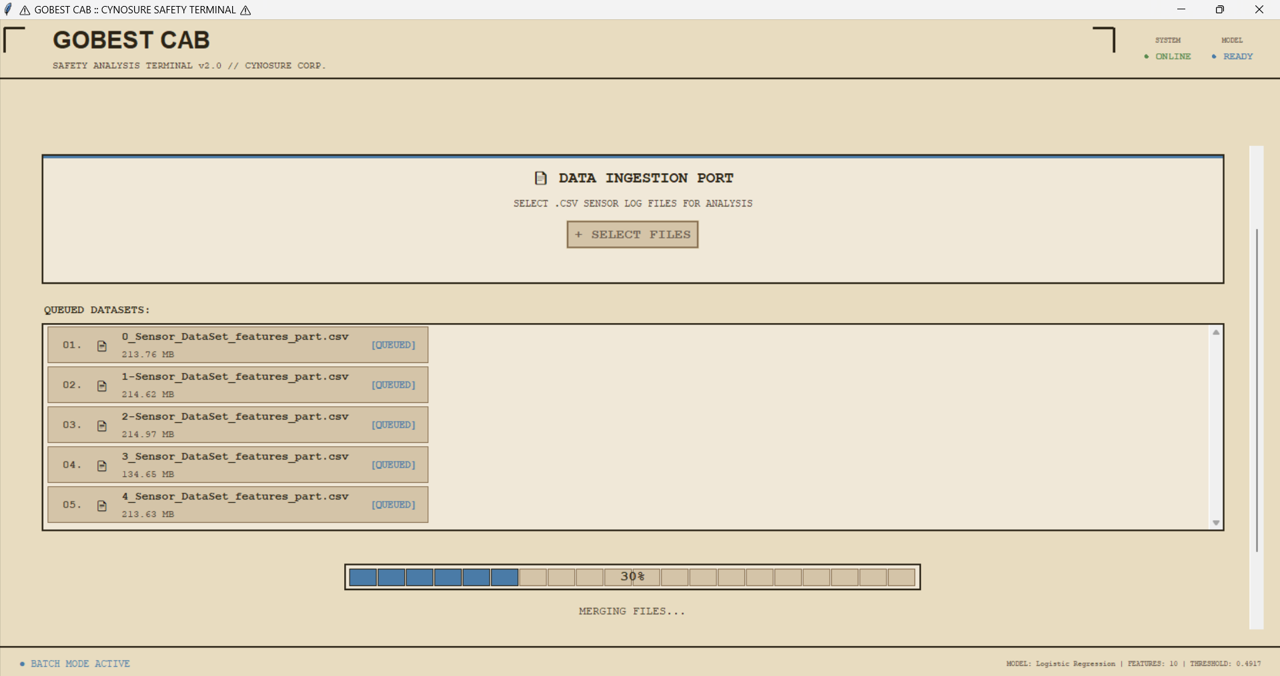
B. Incident Review Mode (Safety Analyst)
This mode features a manual diagnostic form for deep-dive investigations. The analyst can input raw readings from a specific trip, and the system instantly returns a "Safe" or "Dangerous" verdict with a calculated confidence score, allowing for immediate assessment during driver reviews.
C. User-Friendly & Offline GUI (Company Manager)
The entire application is packaged as a standalone desktop tool. This ensures that non-technical staff can utilize the AI system easily without needing Python knowledge or cloud connectivity, fulfilling the need for a simplified, secure, and offline workflow.
D. Summary Statistics & Export (Fleet Manager)
To support data-driven fleet policies, the application automatically aggregates results into summary statistics, such as the total percentage of dangerous trips. These results can be exported as finalized CSV reports for safety trend analysis and driver training programs.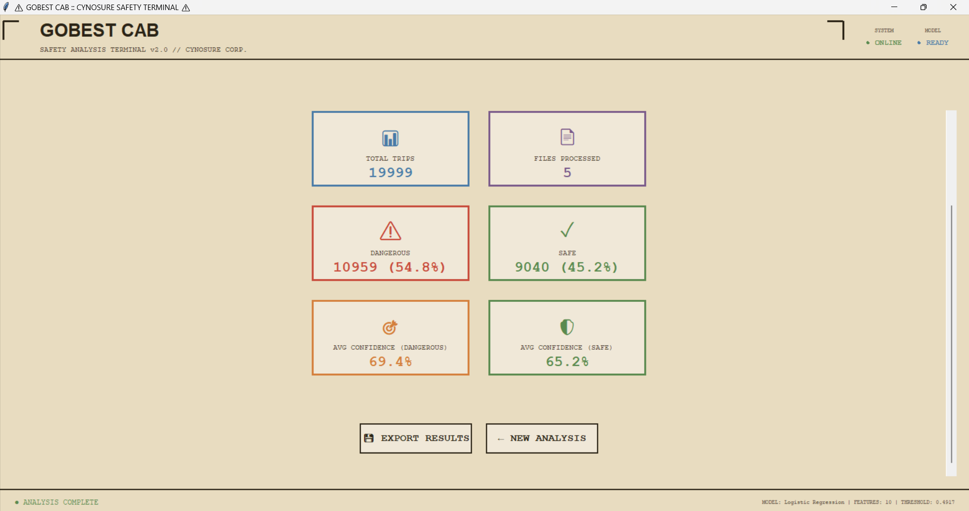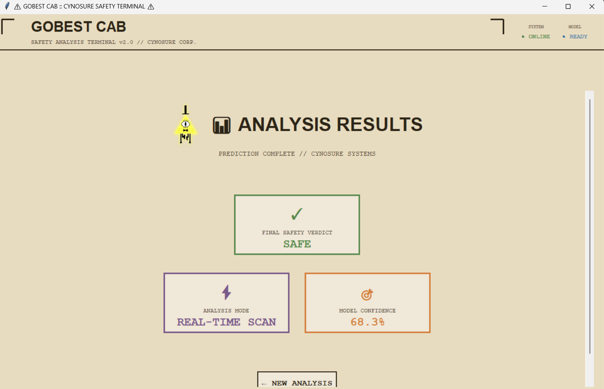
4.4. System Assumptions, Constraints & Limitations
Defining the technical boundaries of the safety terminal ensures its reliability in a production environment.
- Data Schema Assumption: The system assumes that all uploaded telemetry files strictly follow the defined column naming and unit standards (e.g., speed in km/h) to ensure mathematical accuracy.
- Feature-Locked Logic: The current version is optimized specifically for the 10-feature subset. Any sensor data provided must contain the raw inputs necessary for the DataProcessor to calculate these specific interaction features.
- Post-Trip Analysis: The system is designed for batch processing and manual incident review; it does not currently support real-time streaming of data directly from a moving vehicle.

